AN AUSTRIAN SCHOOL VIEW ON EUCKEN’S ORDOLIBERALISM

Analyzing the Roots and Concept of German Ordoliberalism from the

Perspective of Austrian School Economics

PATRICK REIMERS*

*Fecha de recepción:* 30 de noviembre de 2019

*Fecha de aceptación:* 22 de febrero de 2020

*Abstract:* This paper explains the origins and the theoretical concept of Ordo- liberalism, focusing in particular on one of its founders, Walter Eucken. We will focus on the political and economic concepts of Ordoliberalism in regards to interventionism, competition, monopolies, democracy and property rights. For a better understanding, we will compare its main positions and rationale with both, the concept of a social market economy, as well as with the theoretical background of the Austrian School of economics. We pretend to define how much State is necessary to assure a long-term maximization of human rights and individual liberty, while also evaluating at what stage a State becomes too big, potentially turning into a totalitarian autocracy.

*Keywords:* democracy, Private Property Order, Hoppe, Hayek, Wilhelm Röpke, Walter Eucken, Franz Böhm, Müller-Armack, Ludwig Erhard, Ordoliberalism, Ordo, Mont Pèlerin Society, human rights, liberalism, libertarianism, Austrian school of economics, anarcho-capitalism

*JEL Classification:* A12, B10, B13, B25, H10, H40, K11, P10, P14, P16, P26, P48, P51

* Patrick Reimers, MBA and Master in Austrian School Economics. Patrick is also holding an M.A. in Philosophy (Maestría en Filosofía) from Universidad Francisco Marroquín (UFM) and is currently a Ph.D. student at Universidad Rey Juan Carlos (Doctorado en Ciencias Sociales y Jurídicas).

*Procesos de Mercado: Revista Europea de Economía Política*

Vol. XVII, n.º 1, Primavera 2020, pp. 13 a 53

*Resumen:* Este artículo explica los orígenes y el concepto teórico del Ordolibe- ralismo, centrándose en particular en uno de sus fundadores, Walter Eucken. Nos centraremos en los conceptos políticos y económicos del Ordoliberalismo con respecto al intervencionismo, la competencia, los monopolios, la democra- cia y los derechos de propiedad. Para una mejor comprensión, compararemos sus principales posiciones y razones con el concepto de economía social de mercado, así como con los antecedentes teóricos de la Escuela Austriaca de economía. Pretendemos definir cuánto Estado es necesario para asegurar a largo plazo una maximización de los derechos humanos y de la libertad indi- vidual.

*Palabras clave:* democracia, propiedad privada, Hoppe, Hayek, Wilhelm Röpke, Walter Eucken, Franz Böhm, Müller-Armack, Ludwig Erhard, ordoliber- alismo, Ordo, Mont Pèlerin Society, derechos humanos, liberalismo, liber- tarismo, Escuela Austriaca de economía, anarco-capitalismo

*Clasificación JEL:* A12, B10, B13, B25, H10, H40, K11, P10, P14, P16, P26, P48, P51

I

AN INTRODUCTION TO ORDOLIBERALISM

Ordoliberalism significantly shaped the economic model of west- ern Germany throughout the 2nd half of the 20th century. Never- theless, on a global level ordoliberalism has received significantly less attention and even in the Federal Republic of Germany, since the late 1960s, the academic focus on Keynesianism as well as Chicago School / monetarist theories gained more relevance in business schools and university lecture halls. However, with the beginning of the Global Financial Crisis of 2008 the term “ordo- liberalism” has experienced a certain revival, in order to define ‘a 3rd way’, a new economic model which should ‘guarantee basic rules for the (financial) markets’ while still protecting individual freedom and free competition. Often, this interest in ordoliberal- ism is closely related to the desire to combine the liberal approach to maximize free trade and private property with the so-called ‘essential responsibilities’ of the State, and minimized but needed

forms of economic regulations. We will show that ordoliberalism does not only suggest a need for regulation but that it also pro- vides guidance on its substance. Ordoliberalism’s main concern is not on “how much” but “what kind of” interventions are needed. Thus, it has distinct normative and substantive features which must be seen as relevant, also in the 21st century. It sup- ports a market order with a regulatory framework created by the state to ensure economic competition while protecting citizens from an excessive power concentration. (White, 2010) In this paper, we pretend to detect similarities and differences not only between the theory of ordoliberalism and the ‘social market econ- omy’, but also between ordoliberalism and the Austrian school of economics. We pretend to show that the theoretical concept of ordoliberalism is in several aspects different to the social market economy implemented in Western Germany after WWII, and will also focus on certain differences and similarities between Walter Eucken and F.A. von Hayek. By looking at Eucken’s ordo- liberalism and Hayek’s concepts, as well as at the Austrian school approach of Murray Rothbard and Hans-Hermann Hoppe, we pretend to analyse and compare these different theories, in order to evaluate their strengths, weaknesses and potential inconsist- encies. Based on these questions we pretend to evaluate, differen- tiate and explain the different concepts (lat: ‘bene docet, qui bene distinguit’). The main question, which can also be seen as the central theme of this paper, is: “How much State is necessary to assure a long-term maximization of human rights and individual liberty?” How much State is necessary to avoid a ‘modern feudal- ism? On the other hand, at what stage does the State become too big and influential — initially only appearing to be a “progres- sive” (interventionist) welfare state democracy, while potentially ending up in a totalitarian autocracy? Special attention is paid to the ideas of Walter Eucken, Wilhelm Röpke, F.A. von Hayek, Murry Rothbard and Hans-Hermann Hoppe. All of them pub- lished impressive researches and articles and share a profound scepticism towards increasing statism. In such interventionist states, the ‘remedy’ given by public institutions is often worse than the ‘disease’. All these personalities (have) strongly opposed socialism and fascism, emphasizing on strengthening individual

rights, individual freedom, competition and free trade. However, they differ in their interpretations of how this can best be achieved. Whereas Eucken considered a slim but strong State as necessary, highlighting his concerns towards pure laissez-faire capitalism and potential private monopolies, Hoppe considers the complete abolishment of any public structures as the ultimate goal for a truly free society (the ‘private property order’). We will evaluate on which aspects these 5 thinkers were aligned and on which issues they strongly disagreed. We pretend to examine the advantages and disadvantages of public structures & services.

We intend to detect whether the concept of ordoliberalism, in which the state should act as a referee to assure the proper behav- ior of all market forces, must automatically lead to increasing state interventionism with expansionary social policies. Thus, we can raise the following questions: “Must ordoliberalism within a dem- ocratic system automatically lead to an overwhelming welfare state and increasing public interventionism? And, moreover, is the current social market economy in Germany rather based on the ideas of ordoliberalism or on keynesianism?” When evaluat- ing the politico-economic concepts of the Austrian School of Eco- nomics, apart from F.A. von Hayek, also Ludwig von Mises must certainly be considered. Thus, we will carefully review Mises’ *Human Action: A Treatise on Economics* (1949) as well as his *Nation, State, and Economy: Contributions to the Politics and History of Our Time* (1919). Also Israel Kirzner’s *Competition and Entrepreneurship* (1973) and Huerta de Soto’s *The Theory of Dynamic Efficiency* (2009) are helpful to detect core aspects of the Austrian School concepts. In regards to the concept of Ordoliberalism, we will in particular evaluate aspects mentioned in Eucken’s *Technik. Konzentration und Ordnung der Wirtschaft* (1950) and Roepke’s *A Humane Economy* (1971).

Ordoliberalism can be seen as a quite sophisticated and thor- ough theory which is not just an economic concept, as it combines legal, political, philosophic and economic aspects. The concept was essentially developed by ‘Freiburg School of Economics’ such as Walter Eucken, Franz Boehm, Leonhard Miksch and Hans Grossmann-Doerth. Even if it was initially rooted in classic liberal- ism it was then further developed to define a ‘3rd way’ between

centralized interventionist states on the one hand, and the concept of complete *laissez-faire* on the other hand. The state should shape the general order of an economy, but it should not directly steer the actual economic processes (Vanberg V. , 2011). Or as W. Eucken said: “The State planning the general order? Yes! But the State plan- ning and steering the economic process? No!” Interestingly, the term “ordoliberalism” was established by Hero Moeller in 1950, based on the journal *ORDO — Jahrbuch für die Ordnung von Wirtschaft und Gesellschaft*. It was first published by Walter Eucken

& Franz Böhm in 1948 and does still exist. *ORDO* is a peer-re- viewed academic journal, which has been focusing on economic and political issues, providing a forum of debate for scholars. Con- tributors include famous figures such as James M. Buchanan, Mil- ton Friedman, Friedrich von Hayek, George J. Stigler, Ludwig Lachmann, and Karl Popper.

Image n° 1: EDITIONS OF ‘ORDO — ANNUAL JOURNAL ON ECONOMICS’

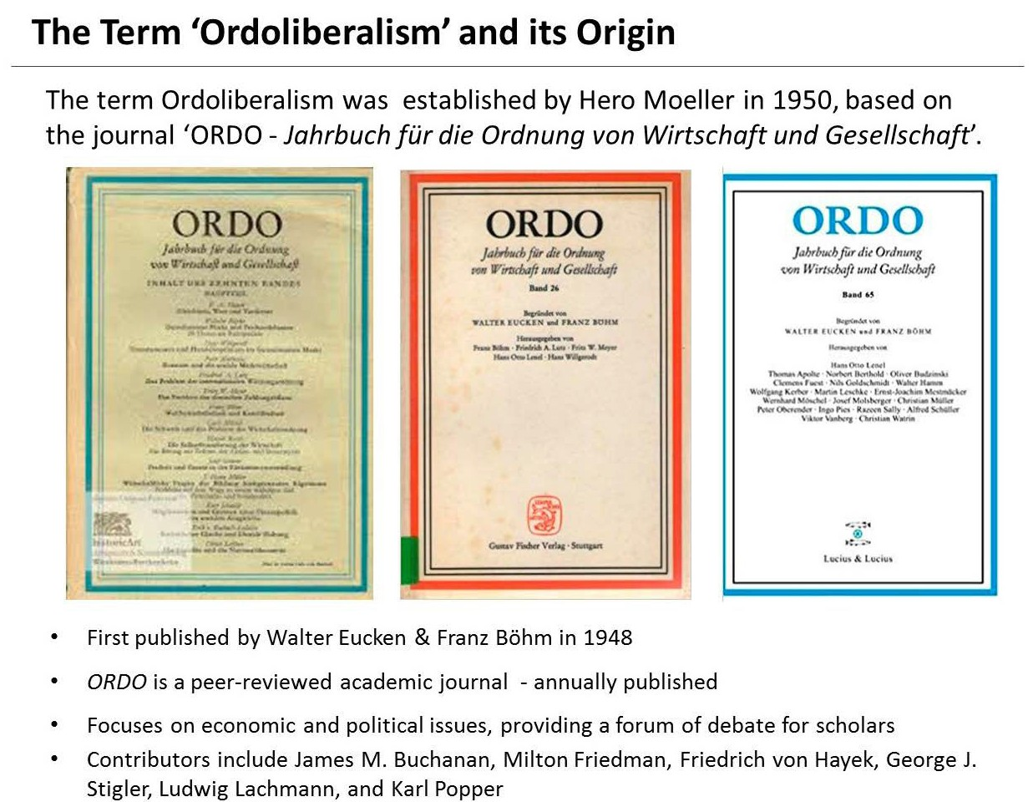

The concept of a social market economy was significantly developed through papers published in *ORDO*. We will evaluate the origins of the ordoliberal concept, by strongly looking at its most famous thinker, Walter Eucken. We will then investigate how ordoliberalism shaped the concept of the ‘social market economy’, implemented in Germany after WWII by Konrad Ade- nauer and Ludwig Erhard. Moreover, we will evaluate the cri- tique towards ordoliberalism by several ambassadors of the Austrian school of economics and will draw our consequent con- clusions.

II

WALTER EUCKEN — A SHORT INSIGHT INTO HIS LIFE, THOUGHTS & CONCEPTS

Walter Eucken (* 1891, † 1950) contributed significantly to the development of Ordoliberalism, which aimed to assure a sustain- able maximization of liberty and freedom “within a fair and com- petitive order” (Böhmler, 1998). His conception of a regulatory policy is based on enormous theoretical achievements — espe- cially in the field of the ethics of order (*Ordnungsethik*). Walter Eucken had already been equipped with an enormous educa- tional academic background by his parents. Being the son of the philosopher and Nobel laureate Rudolf Eucken, Walter Eucken had a thorough knowledge of the writings of Kant and Hegel as well as a familiarity with the philosophy of Edmund Husserl. Walter Eucken was socialized in the philosophy of his father’s life while then developing his own concepts, in particular regard- ing the economic order.

Eucken began his career as a single scientist in the context of the ‘historical school’ of political economy and had due to this scientific socialization a comprehensive reservoir of philosophi- cal-historical and legal-historical and especially economic-his- torical knowledge. After the pogrom of *Reichskristallnacht* in 1938, Dietrich Bonhoeffer who was a key figure of the resistance against Hitler, asked Eucken and other economists to define a possible ‘post-war economic and social order’ which should

ideally be implemented after a possible collapse of the Nazi regime. In this concept, the central planning system of the Nazis was to be replaced with a liberal competitive system. Right after World War II, Eucken’s theories significantly influenced eco- nomic reforms in western Germany, as Eucken was already a member of the advisory council to Ludwig Erhard, then eco- nomic director of the American-British zone of occupation, help- ing to reshape and rebuild the German economic system (Oliver, 1960). Eucken also attended the founding conference of the lib- eral Mont Pèlerin Society of which he was elected one of the vice-presidents (Hartwell, 1995). His own thinking ‘in orders / structures’ is explicitly based on the legal thinking in political constitutions, and it is no coincidence that Eucken worked closely with the jurists Franz Böhm and Hans Großmann-Do- erth. In this form of inter-disciplinarity one can detect a fore- runner of what was later developed in the US as “law and economics”.

Unfortunately, the common understanding of Eucken in today’s economic science is rather small. Eucken’s theoretical work is not based on the level of concrete modelling that is considered par- ticularly important today. However, Eucken’s concept was based on a clear methodology, theory architecture and conception of sci- ence. In his thinking on philosophical and methodological prob- lems, Eucken was related to Husserl. His theory of the economic order (*Ordnungstheorie*) is interdisciplinary. Several of the modern directions in economics, such as property rights theory, evolution- ary economics and new institutional economics, can be integrated in his methodological approach. Eucken’s concept of Ordoliberal- ism pretends to limit the economic centralization of power by indi- viduals, companies and associations (Vanberg V. , The Freiburg School, 2011). This should be achieved with a legal and institu- tional framework, which defends private property, while high- lighting the enforcement of private contracts, liability, free entry to markets, and monetary stabilization (Eucken, 1949). Walter Euck- en’s regulatory policy is based on a diagnosis of modernity, in which he looked from a universal perspective on the long-term development of society and identified a radical break, for which already in 1948 Eucken wrote: “Industrialization and modern

technology have led to a unique overthrow in history: The eco- nomic-technical environment of each person has changed com- pletely; the environments of Goethe and Plato were more similar to each other than the environments of Goethe and a man alive today.” For Eucken, industrialization and modern technology have a crucial effect, not just on the economic wealth that they allow, but above all because of their societal consequences. These conse- quences influence the freedom of each individual — in particular the possibility to lead a self-determined life — up to the possibility of defining and defending a democratic constitution. Especially in the years immediately after the Second World War, it is undeniable for him that from scratch new solutions would need to be found. First of all, the challenge of (economic) scarcity must be success- fully mastered. Secondly, the individuals must be given a moral self-determination. And thirdly, a permanently stable constitu- tional democracy must be made possible. For Eucken, the most important aspects of political decisions are related to economic policies, which at the same time are social order policies. Both eco- nomic and social policy belong together from his point of view, because he assumes an “interdependence of orders”. Therefore, one must at the same time keep an eye on the economy as well as on the society in order to be able to take into account the respective repercussions between these two orders *(Eucken, Technik, Konzen- tration und Ordnung der Wirtschaft*, 1950).

In the last 18 years of his life (from 1932 to 1950) Eucken devel- oped a regulatory conception that has the argumentative structure of a social contract theory. Long before James Buchanan with his theory of democracy and John Rawls with his theory of justice, who revived the tradition of thinking in terms of social contract theory, Eucken had already developed such a concept. In the mid- dle of the 20th century, Eucken criticized the general contemporary political discourse which was split between two radical positions: On the one hand, a laissez-faire liberalism entirely based on the self-governing forces of the market, promoting a state-free econ- omy. On the other hand, a central planning socialism, rejecting the market and asking for more public interventionism. Eucken him- self considered this confrontation as over-simplified, misleading and useless. He stated that the controversy overlooked that there

was a third option, by overcoming the one-dimensional dispute between the two known radical extremes. To assure both social security and social justice, Eucken’s recommended to maintain individual freedom, rejecting the threat of an overwhelming state which strongly centralizes all planning. Instead, he sees the state’s main role in regards to economic policies in protecting the market order and its competition. Since the times of Nazi Germany, the threats to safety and freedom have primarily been caused by too much state power, which often led to totalitarian states.

III

“SHAPING THE ECONOMIC ORDER, NOT STEERING ITS PROCESS”

Eucken asked for a two-dimensional view, distinguishing system- atically between “the general form” and “the individual processes” of economic activity — referring to the difference between the general basic ‘rules of the game’ and the individual ‘moves during the game’. Eucken’s argument in favour of ordo-liberalism can be detected in the following passage:

“Should the state do little or nothing, more or less? Well, “very lit- tle or nothing!” is how the supporters of Laissez-faire respond: “A lot, much more!” is what the supporters of the economic policy of central planning state. And in between, the friends of compromise solutions seek a middle ground. [...] But the problem should be put differently in order to be solvable. Whether ‘little or more state activity’, is not the real question, as it ignores the essence. It is not a quantitative, but a qualitative problem. [...] So what kind of state activity do we need? The answer is: The state shall shape the gen- eral format in which the economy is developing, but the state must not steer the economic process itself. [...] Thus: we say ‘yes’ to the state planning the format, but ‘no’ to a state steering the economic processes. Seeing the difference between defining the general for- mat and acting in these processes is essential.”

In Eucken’s concept, the state should provide a well-function- ing competitive order in which private agents can act without

frequent discretionary influence from the state. *(Eucken, Grundsätze der Wirtschaftspolitik*, 1952)

Generally, there are three values for Eucken that should be cru- cial criteria for the definition of constitutions: social justice, social security & freedom.

The first aspect — social justice — goes back to the time from the beginning of industrialization until the year 1914. Eucken looked primarily at the problem of inequality, especially in the form of a low standard of living for simple workers. The government response to this was a comprehensive social policy. The spectrum ranged from occupational health and safety legislation to the establishment of collective systems to cover illness and accident risks.

The second variant of the social question –Social Security — is looked at, especially in regards to the period from 1914 to the mid-1930s. Eucken looked primarily at the problem of mass unemployment, to which governments responded with a new form of social policy that aimed at full employment, largely dis- torting the market while introducing central planning elements. Such strongly interventionist state economy caused totalitarian consequences and thus led, from Eucken’s point of view, to threatening the third mentioned aspect: “freedom”. In this regard, Eucken looked primarily at the threats to individual freedom.

For Eucken, a ‘liberal, competitive order’ offers a double advan- tage: First, it solves the problem of state power concentration, because the state would be sufficiently limited to focus primarily on defending the constitutional state. That shift ‘from subordina- tion to coordination’ directly benefits individual freedom. At the same time, however, Eucken’s competitive order also avoids the threat of too much concentration of power in private hands (pri- vate monopolies…etc.). Eucken argues that a completely free econ- omy would ultimately hamper long-term competition, creating private monopolies which would hamper consumers and entire economies.

“The economic activity of the state should be aimed at shaping the order of the economy, not at the direction of the economic pro- cess.” (Walter Eucken)

It is this double effect of a functioning ‘competitive order’, the simultaneous dismantling of too much centralized state and monopolized private power, which Eucken had in mind.

IV

THE ‘THIRD WAY OF THE FREIBURG SCHOOL’

Eucken believed that after the “negative experiences with the con- cepts of classical liberalism in the 19th century”, as well as with the interventionism of the Weimar Republic and the centralist, coer- cive national socialist dictatorship, a new idea for the organization of the economy was needed. Fundamental unity of both thinkers, is the critical distance to the *laissez-faire* liberalism, as well as towards a strongly interventionist government steering a centrally managed economy. For Eucken, the threat to the freedom of the individual through economic and political power represents the central problem of economic and social policies. This problem should be solved through a lean, but functioning and effective reg- ulatory framework. This framework should be beneficial to eco- nomic development as well as to human freedom and should oppose any form of centralized coercive public or private power (Vanberg, 2004). Böhm, Eucken and Großmann-Doerth stated as their guiding principle that the “treatment of all practical politi- co-legal and politico-economic questions must be keyed to the idea of the economic constitution”, for which the collaboration of law and economics is essential. From the perspective of the ‘Freiburg school’, the market, if protected by a ‘market order’ which assures competition, is generally a non-discriminatory, privilege-free and therefore good, ethical and fair order.

Ordoliberalism [also known as the “Freiburg School” and asso- ciated with the names Walter Eucken (1891-1950), Franz Böhm (1895-1977), Leonhard Miksch (1901-1950), and Hans Gross- mann-Doerth (1894-1944)] was seen as the ideal compromise between capitalism, private property and individual freedom on the one hand, and “social justice” on the other hand. Several cru- cial books and papers were written & published between the 1930’s and 1960’s which had a significant impact on ordoliberalism as

well as on the initial concept of ‘neo-liberalism’ which we will describe at a later stage of this paper.

Chart n° 1: ORDOLIBERALISM AND ITS CONCEPT FOR THE AVOIDANCE OF CENTRALIZED POWER

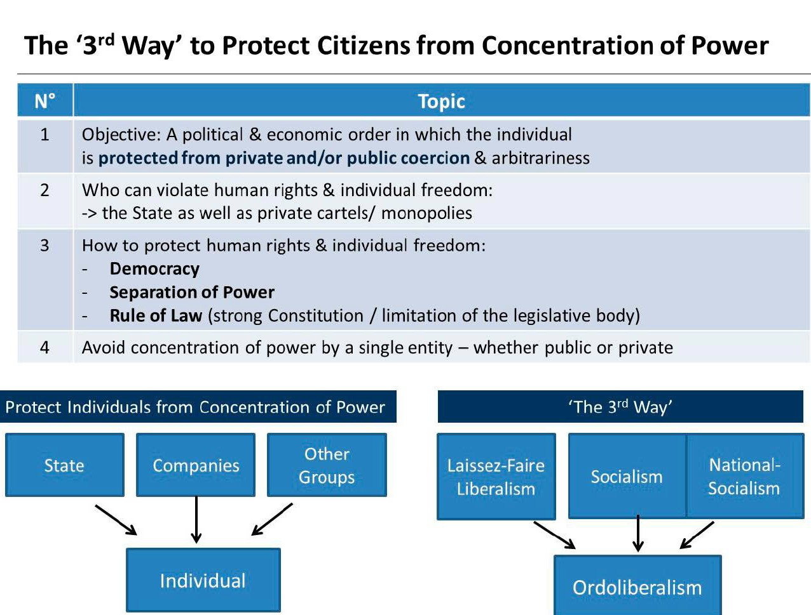

*Source: Author’s own image*

Walter Eucken was strongly focusing on creating a decent and functional order which unites political and economic freedom. From the point of view of the ordo-liberals, the free market economy can promote material well-being in the best possible way, but a com- pletely free market economy could also ultimately abolish itself by centralizing economic power (private monopolies), price fixing, antitrust etc. which would then destroy free competition. Thus, a completely free market without any public control could lead to pri- vate monopolies in the long run, making true competition impossi- ble. To avoid this, there would be a need for an institution which sets

the framework under which the competition can run smoothly. And that institution would need to be the State. For example, a cartel office would be crucial to make it impossible for one single company (or for oligopolies via price fixing) to fully dominate the market.

The following chart defines the interdependence between poli- tics, society and the economy, and shows from an ordoliberal point of view, in which areas the State must be present.

Chart n° 2: ORDOLIBERALISM AND ITS REGULATORY PRINCIPLES

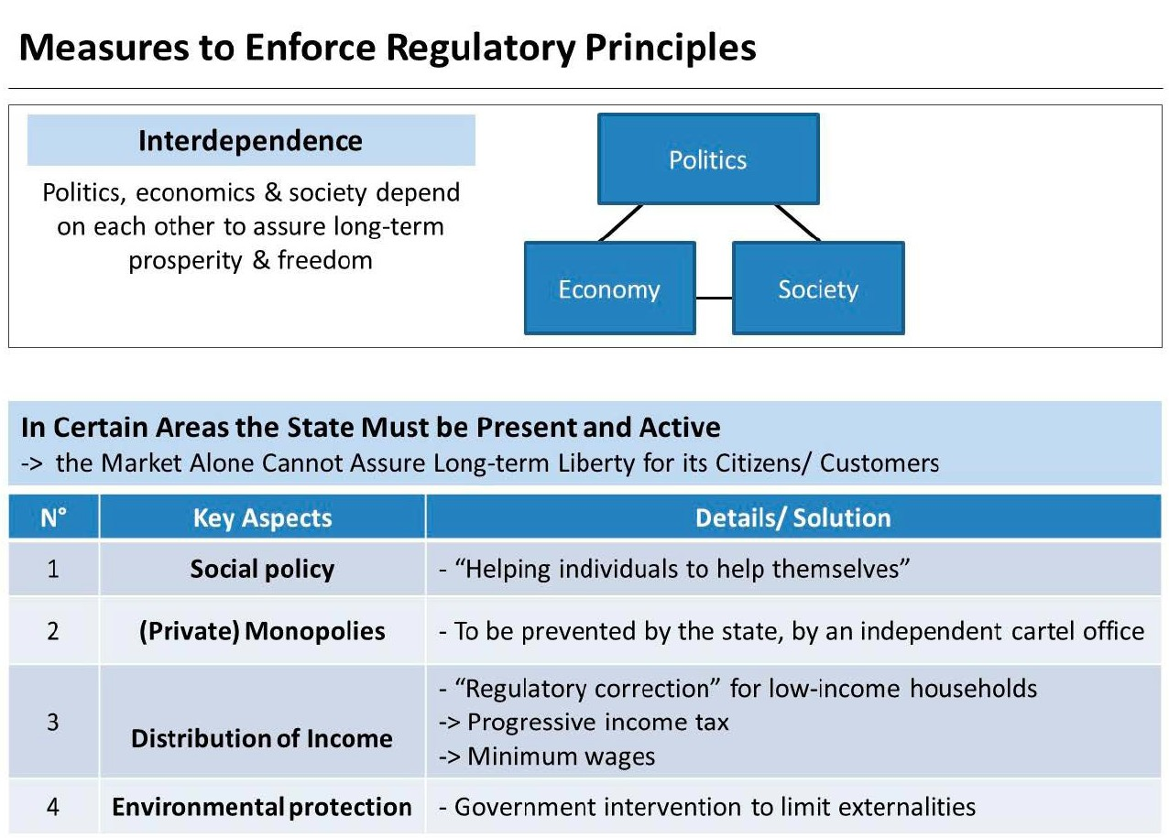

*Source: Author’s own Image*

In this aspect, the ordo-liberals consider the State as crucial to protect the free market system. Such control would ultimately assure a functioning market economy, by protecting citizens / con- sumers from the supposedly destructive forces of the free market.

Thus, in regards to economic policy, the key question for ordolib- erals was: How to assure a long-term political & economic liberty? For this, all below-mentioned aspects must be considered and optimized.

Chart n° 3: BASIC PILLARS OF ORDOLIBERALISM

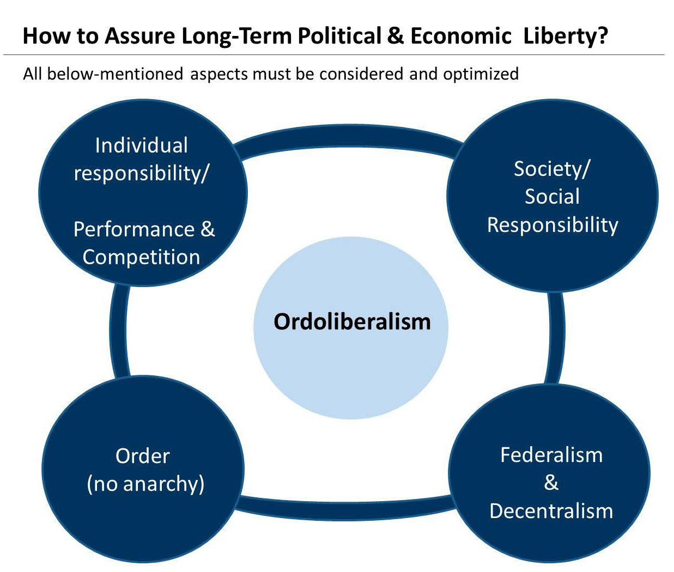

*Source: Author’s own design*

For further clarification, we can detect the basic principles of ordoliberalism & for a functioning competitive order. From an ordo- liberal perspective, the following aspects are needed to achieve a proper economic (price) system with “perfect competition”.

Chart n° 4: ORDOLIBERALISM’S ‘PERFECT PRICE SYSTEM AND PERFECT COMPETITION’

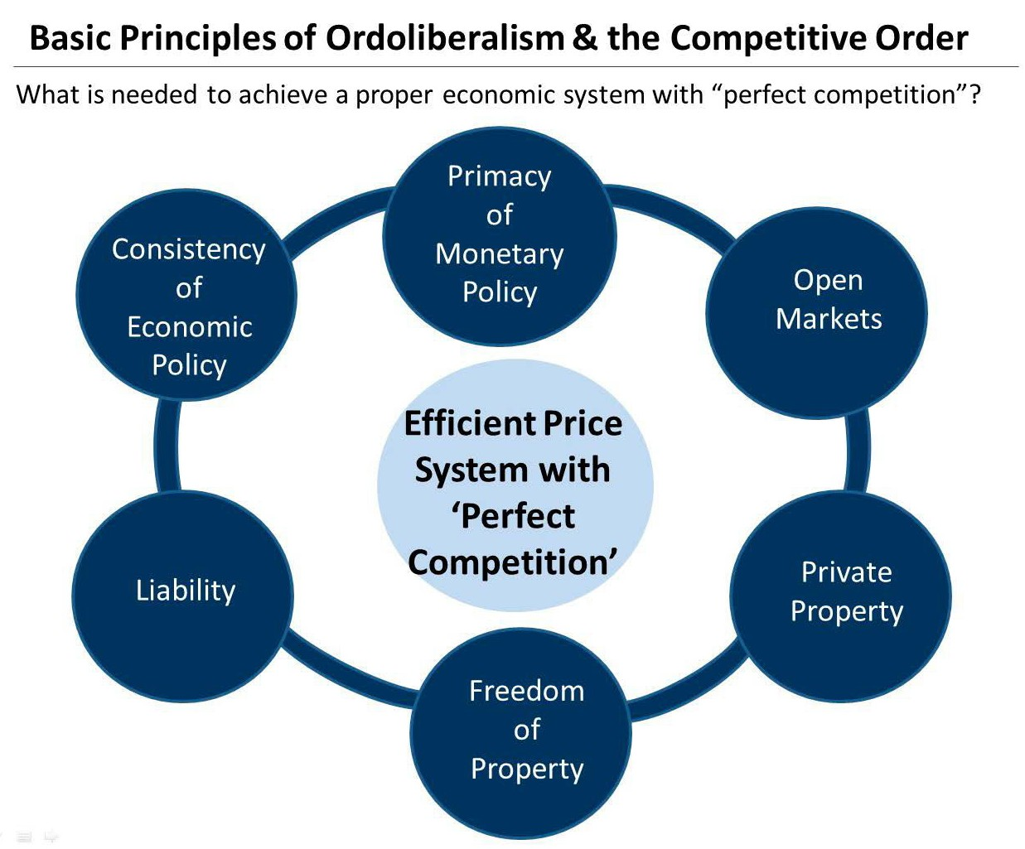

*Source: Author’s own design*

V

THE ORIGINS OF THE SOCIAL MARKET ECONOMY

Ludwig Erhard’s economic policy ideas have a close connection with the so-called concept of ‘ordoliberalism’, which nowadays many economists, politicians and journalists consider as a syno- nym of the term ‘social market economy’. However, a comparison of the concepts of ordo-liberalism and the “social market econ- omy” set-up in Germany after the Second World War shows rele- vant differences in some crucial aspects. The main ethical postulates of the founders of ordo-liberalism, including Eucken and Böhm, were different in several aspects to the social market economy implemented in post-war Germany (Zmirak, 2002).

When the term ‘social market economy’ is mentioned, many probably think immediately of Ludwig Erhard (1897 — 1977) and the German “economic miracle” (*Wirtschaftswunder*) which occurred in the period from 1948 to the early 1960s. On Friday, June 18, 1948, the military governments of the three Western zones (USA, UK, and France) which occupied the Western part of Germany announced the currency reform. On the following Monday, the German Mark replaced the Reichsmark. However, without the prior consent of the Allies, Ludwig Erhard (Director of the British-American Zone Economic Authority) announced on his own initiative the cancellation of state price controls on that day of the currency reform. This was the actual starting sig- nal for the economic miracle: Now that the prices for goods were ‘free’, meaning that they were freely defined on the market, com- panies started to produce, and demand for labour was on the rise. With this freedom, Germans finally saw an opportunity to work themselves out of the crisis and poverty into their economic resurgence.

“The blindness and intellectual negligence with which we are heading for the welfare and welfare state can only turn us to dis- aster.” (Ludwig Erhard)

# 1. Müller-Armack & the Actual Origin of the Term ‘Social Market Economy’

As stated the term “social market economy” is usually associated with Ludwig Erhard. However, Erhard neither invented the term nor did he focus much on using it for political purposes. In fact, the term “social market economy” was defined by the German econo- mist Alfred Müller-Armack (1901 — 1978). On page 59 of his book *Wirtschaftslenkung und Marktwirtschaft* published in 1947, the term “social market economy” can be found. In his book, Müller-Ar- mack supported an economic model that seeks to strike a balance between socialism and pure capitalism.

Thus to summarize our finding up until this stage, while the general ideas of the social market economy are often attributed to

Eucken and other economists such as Franz Böhm and Hans- Großmann-Doerth who represented the so-called ‘Freiburg School’, it was Müller-Armack who defined the term “social mar- ket economy” while in practical politics the concept was taken up and implemented by the then acting Federal Minister of Econom- ics in Germany, Ludwig Erhard.

The Freiburg School is often subsumed under the generalized term of “(German) neo-liberalism”, and even academic papers do not always properly distinguish between Müller-Armack’s ‘social market economy’, and the original concepts of neo-liberalism as well as ordoliberalism. However, there exist clear relevant differ- ences between these terms and concepts. As we learned, Ordolib- erals separate themselves from classical liberals, as they promote a relevant role for the state with respect to the set-up of the market framework. The term ‘neoliberalism’ was originally coined in 1938, at the Colloque Walter Lippmann, by Alexander Rüstow, who him- self was regarded an ordoliberal. The term “neo-liberalism” was meant benevolently as an alternative to “classic liberalism”, as this “new” form of liberalism was seen as capable to avoid inefficient concentration of power by public institutions as well as by private corporates. The colloquium defined the concept of neoliberalism as appreciating “the priority of the price mechanism, free enter- prise, the system of competition, and a strong and impartial state”. Due to this connected history, ordoliberalism is often referred to as “German neo-liberalism”, which has led to confusion and “mix ups” of terms and ideas in the politico-economic discourse.

In regards to the difference between ‘ordoliberalism’ and the ‘social market economy’, a comparison between Walter Eucken and Alfred Müller-Armack is of interest. On the one hand, Müller-Ar- mack developed a distanced relationship to Walter Eucken’s ideas when developing his social market economy, but on the other hand, it cannot be ignored that Müller-Armack included several of Euck- en’s ideas into his own theory (Müller-Armack, 1947).

Müller-Armack’s concept of the social market economy was in some aspects more interventionist and outcome-oriented than the original concept of ordoliberalism. The ordoliberals of the Freiburg School advocated a strictly procedural and rule-oriented liberalism. In a simplifying way, one may say that the difference between the

ordo-liberalism of the Freiburg School and Müller-Armack’s con- cept of the social market economy can be seen in the room given to the political system to steer the economy and society via interven- tionist policies (Vanberg V. , *The Freiburg School,* 2011). For the Frei- burg School, government shall focus on protecting a competitive market order, as this market order, being a non-discriminating, privilege-free order of competition, is by itself an ethical order. In regards to the concept of a “social insurance”, the Freiburg ordo-lib- erals recognized that the competitive market order could be com- bined with a system of minimal income guarantees for those whose services / work force is simply not requested by and competitive in the market. However, they also clearly insisted that such social insurance provisions must be of a non-discriminating, privilege-free nature, and must not be provided in ways which corrupt the funda- mental ethical principle of the market order, namely its privi- lege-free nature. Contrary to that, Müller-Armack, defined the market order as an economically efficient order, but not as one which would have any inherent ethical qualities. Müller-Armack’s “social market economy” concept is not a general philosophy based on nor justified by ethics. It is only a “technical tool” which can be (politi- cally) used to produce wealth, but the concept as such cannot be seen as generally ethical nor as automatically good for society. Therefore, it has to become “ethical” by supplementary policies, in particular “social” policies. The important point is that in Müller-Ar- mack’s case, these supplementary “social provisions” are needed to make the market economy (beyond its economic efficiency) also eth- ically appealing. Thus, he considers certain “social supplements” necessary, while at the same time these supplements are not thor- oughly explained, nor clearly limited in his concept. In this aspect, Müller-Armacks social market economy can be defined as a rather “pragmatic”, result-oriented political-tool which can be adjusted to political, economic or social changes. This would distinguish it from Ordoliberalism which can be rather seen as a general theory, and which considers competition in itself to be ethical, since a function- ing competitive market is seen as ‘ethical’ without any additional constant socio-political beneficence. In regards to the development of the “social market economy concept” in Germany throughout the past decades, one may argue that precisely Müller-Armack’s lack of

a clear general theory and his concept’s “flexibility” to political and cultural changes has led to more political interventionism, a more excessive welfare state, a growing public expenditure quota and increasing taxation. Contrary to that, the Freiburg ordoliberals emphasize on the importance that public intervention, even if meant for “social projects” must never be in conflict with the privilege-free nature of the rules of the competitive market.

VI ORDOLIBERALISM VERSUS AUSTRIAN

SCHOOL ECONOMICS

In this chapter, we will analyse the similarities and differences between Eucken’s interpretation of Ordoliberalism and the ideas of major representatives of the Austrian school of economics. We do not pretend to create any artificial differences between the dif- ferent great minds within the Austrian school of economics, but we will distinguish, if considered necessary, between F.A. von Hayek’s approach and the rather anarcho-capitalist interpretation of M. Rothbard and H. Hoppe.

# The Mont Pelèrin Society — Eucken & Röpke versus von Mises & Hayek

There have been quite different interpretations of what liberalism is actually all about. These differences have been visible at several of the meetings held by the Mont Pèlerin Society, the interdiscipli- nary group of liberal scholars which F.A. Hayek had first brought together in 1947 at Mount Pèlerin in Switzerland. Since the found- ing session of the Mont Pèlerin Society in 1947, it had been shaped by three major schools of thought: the Austrian School, ordo-liber- alism and the so-called Chicago School. Mises and Hayek repre- sented the Austrian School, while Walter Eucken and Wilhelm Röpke represented ordo-liberalism, and ultimately George Stigler, Frank Knight and Milton Friedman were the main ambassadors of the Chicago School (Bagus, 2016).

Already in 1949, an argument erupted between Ludwig von Mises and Walter Eucken about the question of monopolies, whether private monopolies are a threat to economies and if so, how to deal with this threat. Röpke’s reported about a constant conflict of opin- ion within the Mont Pèlerin Society, initially mainly due to disputes between Eucken and von Mises who represented two distinctively different perspectives on liberalism, competition and the role of eco- nomic policy. While von Mises favoured a more radical concept of the free ‘unhampered market’, Eucken also supported competition, but defending the concept of the market as ‘a constitutional order’.

Already in 1950, von Mises stated: “*I have* growing doubts that it is possible to cooperate with the ordo-liberals’ interventionism in the Mont Pèlerin Society.”

Mises saw all government interferences in the economic process critically as he considered economic policies as “coercion… crucial acts of intervention… and authoritarian decrees and prohibitions” (Mises, 1985: 76). Also Hayek criticized government policies that seek to shape the economic process by means of general rules which he considers as “undesirable or even harmful” (Hayek, 1944). Neither von Mises nor Hayek could be considered as “anarcho-capitalists” as both defended a lean but effective state in specific areas. However, in regards to specific aspects, in particular to free-market monopolies, controversies occurred and remained among the different liberal schools of thought united in the Mont Pèlerin Society. Eucken and Röpke insisted that the market order is a rule-based order, as a mar- ket without any framework of rules and institutions would be a threat to competition and therefore a threat to consumers (Röpke, 1960).

The Austrian school economist Philipp Bagus argues that both the Chicago School and Ordoliberalism could be classified as ‘neo- liberal’. Both schools are against socialism, but also against a pure Manchester capitalism, which means that they oppose the lais- sez-faire of classical liberalism. Bagus argues that both, ordo-liber- als as well as the Chicago School, advocate a lean but strong state, which sets the framework for the market and steers the economy on some paths. They also want the state to provide a relevant degree of social security (Bagus, 2016). We may add that one significant dif- ference between Ordoliberalism and the Chicago School is, that the concept of the Freiburg School’s Ordoliberalism can be seen as

broader, referring to a wider range of aspects related to humanities, social sciences and jurisprudence. Apart from containing an eco- nomic theory, Ordoliberalism is a sophisticated, comprehensive and broad school of thought which combines economic, political, philosophic and legal aspects. Moreover, ordoliberals dedicated more time to the task of the State to assure a competitive market order, as well as to provide specific social policies. Similar to Milton Friedman, also Eucken considered competition in itself to be ethi- cal, since a functioning competitive market is seen as ‘ethical’ with- out any additional constant socio-political beneficence (Eucken, 1949). However, ordoliberals did emphasize on the need for certain social policies, such as financial support to those whose work force was simply not requested / competitive in the market place.

To compare the “Austrian school concept” with Ordoliberalism is rather challenging, as there clearly are different branches within the Austrian school, ranging from Hayek’s ‘institutional evolution’ to von Mises and ultimately including the anarcho-capitalist ‘nat- ural order’ of Murray Rothbard and Hans-Herman Hoppe. For simplification, we will now compare ordoliberalism to the praxeo- logic Misesian-Rothbardian definition:

**N° Ordoliberals versus the ‘Praxeologic Misesian-Rothbardian’ Austrian School**

* 1. Initially, proximity of F. Hayek’s early social philosophy to ordoliberal reasoning
  2. No fundamental rejection of empiric analyses to predict certain future developments
  3. BUT: Main difference to Austrian School: Free markets are not always self-healing
  4. Too much centralized / bundled power (public & private) likely to threaten freedom
  5. -> cartels as a long-term threat to citizens / consumers
  6. -> money control via an independent monopoly office — under the rule of law
  7. Free markets are good, but fragile: State may intervene to preserve competition
  8. Monetary policies: Eucken defended ‘stable monetary policies’ with a central bank
  9. Monetary policy concept of Eucken more similar to M. Friedman than to von Mises / Rothbard

Hans-Hermann Hoppe (born in 1949) is a German-born US-American Austrian School economist, and paleo-libertarian anarcho-capitalist philosopher. Hoppe relies on a “natural order,” which would always arise if the associative power of humans could unfold organically and freely without public interventions and coercion (Hoppe, 1993). Hoppe also opposes the concept of democ- racy, believing that from an economic perspective, even monarchies would be superior to democracy. Hoppe states that democracies are “short-sighted” and destroy willingness to invest through the con- stant increase in taxes, whereas Monarchs on the other hand, have longer-term interests, especially in their own wealth creation. Con- sequently, a long-term sustainable planning is not a priority for any democratically elected government, as only ‘short-term’ are rele- vant for potential re-elections. Thus, the transition from monarchy to democracy is interpreted by Hoppe as a civilizational decline (Hoppe, 1993). He attributes democracy’s alleged failures to pres- sure groups which seek to increase government expenditures and regulations. Hoppe sees democracy as an immoral concept, in which freedom cannot be assured. Moreover, he sees democracy as “dictatorship by the majority”, in which well-structured majorities can basically take away all rights from minorities, as in this concept the majority’s vote could legally justify the implementation of any totalitarian rule. Hoppe believes that no state can ultimately be jus- tified, be it economically or ethically, as every state — regardless of its constitution — is economically and ethically deficient. Moreover, every coercive monopolist is bad from the customers’ viewpoint.

“Democracy has nothing to do with freedom. Democracy is a soft variant of communism, and rarely in the history of ideas has it been taken for anything else….Democracy virtually assures that only bad and dangerous men will ever rise to the top of govern- ment.” (Hans-Hermann Hoppe)

Critics of Hoppe’s anarcho-capitalist concept argue that the lack of a public Police or Military, and the lack of a public jurisdic- tion, could quickly lead to aggressions by private companies equipped with force of coercion, ending up in private — also coer- cive — monopolies.

VII

AN AUSTRIAN PERSPECTIVE: THE DANGERS OF ORDOLIBERALISM & SOCIAL MARKET ECONOMY

# How ‘Social’ is the Social Market Economy?

Looking back, Ludwig Erhard himself did not emphasise on the word ‘social’, instead he clearly said: “The freer the economy can be, the more social it is.” However, even classical liberals must admit that the term “social market economy” was effective in positively using the word “social”. It helped to even convince statist enemies of the free market economy that “a social market economy” would still worry about “those in need”. However, Friedrich August von Hayek had already expressed his concerns, as for him, the word “social” was “probably the most confusing word in our entire moral and political vocabulary” (Hayek, 1988). Hayek called the term “social” a “weasel word”, expressing strong concerns regarding this terminol- ogy, as for him, the word “social” is “probably the most confusing word in our entire moral and political vocabulary”. Hayek believed that, just like a weasel is capable of sucking an egg without leaving an outside trace of its deed, a weasel word can delete or misuse the meaning of any word it prefixes — without the listener noticing. Similarly, the economist Thorsten Polleit criticizes the term ‘social market economy’, as he thinks that, consciously or unconsciously, people would think that if there was a “social market economy” then there must logically also be an “unsocial market economy”. Even worse, if there is a social market economy (and therefore also an unsocial market economy), the concept of ‘a market economy’ is not generally good. Thus, in its ‘original form’ the market economy would then be seen as dangerous and “unsocial.” Based on this rationale, a market economy which does not specifically emphasize on its “social version” is expected to be unkind and merciless. There- fore, the term “social market economy” implies that one must not leave the market economy to itself. Rather, “one” (meaning the State) needs to guide and steer the market so that it can be truly good — that is: social. Jörg Guido Hülsmann agrees with Polleit that by doing so, the idea of “a truly free market economy is secretly discredited.”

However, the precise content of the word “social”, is indefinite and unclear, for which everyone can fill it subjectively with a meaning. There may be a minimum consensus about what is “social”, such as ‘caring not only for one’s own good, but also for the welfare of one’s fellow human beings’. But the ideas of different people about what “social” precisely means can differ so much, that a concrete and detailed definition of “social”, which everyone can agree on, simply cannot be found.

For some, it is “social” if the State “minimizes” its people’s income inequality by imposing progressive income taxation, as well as property and inheritance taxes. Other people may consider politics to be “social”, by simply protecting people’s property rights. Thus, from their perspective, any form of State coercion is evil, and a government is “social” by simply ensuring that transac- tions between people take place on a voluntary basis.

# The Third Way — A Naive Illusion?

Ordoliberalism wants an intermediate path, a “third way” — an economic order that positions itself between socialism and pure free-market capitalism. The ordo-liberals certainly do recognize that the State can become a problem with exaggerated interven- tions into economic affairs. Ordo-liberals confirm that the state can undermine competition, that it can be hijacked by particular interests and that it can lead to an abuse of power. Ordo-liberals were also concerned with the threat of the state becoming the real threat to competition, freedom, peace and prosperity. In regards to the threat caused by too much statism, parallels can be seen between ordoliberals and Austrian school economists like F.A. Hayek.

It was Hayek’s conviction that people are not as good at creat- ing and designing as they often think they are, saying that it is “… the curious task of economics to demonstrate to men how little they really know about what they imagine they can design.” Hayek said that there is no effective way to combine and detect the astro- nomical quantity of information needed to direct economic resources of specific applications properly. He said that there was

not one person, not 1 computer or government that could contain all of the relevant knowledge necessary to detect all scarcity ratios of all goods and services within a certain economy. Therefore gov- ernments will never be able to define new business models, niches, necessities and inventions as quickly and properly as the free mar- ket does. In this aspect, the Austrian Hayek and the ordoliberal Franz Böhm had almost identical views, both emphasizing on that no centralized politico-economic system can be as efficient as the market economy.

“The fact that much more knowledge of facts enters into the order of a market economy than any individual or even any organiza- tion can know is the key reason why the market economy per- forms more than any other economic form.” (Franz Böhm in the *Order of the Economy* (1937))

Hayek proved a key contradiction in socialist thought, which believes that whatever is consciously and purposefully designed by humans shall be more-efficient than any unplanned ‘extended order’. Hayek explored how the theories of John Maynard Keynes are amoral, criticizing Keynes for being opportunistic and short- sighted while explaining that truly free markets are actually more moral than centrally steered markets. Hayek criticized Keynes famous quote “in the long run we are all dead” for being a proof of Keynes’ lack of long-term planning, claiming that Keynes was not interested in the possible long run damage his interventionism could do to economics. In Hayek’s opinion Keynes’ approach was driven by the implementation of actions which could be popular from a short term perspective, while being extremely harmful over the long run. From the end of the Great Depression to the mid- 1970s, Keynes provided the main inspiration for economic policy makers in most European countries and the USA. Consequently, Hayek considers Keynes’ theory of economics as the main reason for the massive economic challenges and inflation seen in the 1970. Also Eucken and other ordoliberals clearly rejected Keynes’ ideas.

Also in regards to the importance of free prices, the positions of Eucken and Hayek were very similar: Both indicated the impor- tance of free pricing, as price signals are the only means to enable

the economic decision makers to communicate (‘tacit’ and / or ‘dispersed’) knowledge between each other, helping to solve the economic calculation problem. Both, Hayek and Eucken, saw the price system as a crucial mechanism to communicate information, as it can assure on a daily basis what centralized systems fail to do: it registers every choice made by the market participants, trans- mitting potential scarcity of products, and consequently coordi- nating the price matrix. Moreover, economic profits must be seen as the reward for removing maladjustments for an economy, for “coordinating” the market. Despite these similarities, there have been fundamental discussions between ordoliberals and Austrian school economists about several aspects, such as the desired role of the state. In particular the ideas of von Mises and his successors such as Murray Rothbard were clearly more radical than those of the ordoliberals in regards to the desired power and size of the state. In his ‘magnum opus’ *Human Action*, Ludwig von Mises (and even more so Murray Rothbard in his *Man Economy and State*) ques- tioned the general influence of the State on economic aspects, such as antitrust laws, clearly differing from Eucken and Röpke. How- ever, some significant differences can also be found between Eucken and Hayek. The author of this paper argues that their most crucial disagreement was on monetary policy and the consequent potential risks and benefits of an abolition of central banks and the establishment of competitively issued private moneys. Hayek’s proposal called for privately issued, competing currencies and the abolition of the current FIAT money system. Eucken did not ques- tion the existence of central banks, and rejected the idea to privat- ize money. However, we must also consider the historic context, as Eucken already died in 1950, whereas Hayek published his fasci- nating pamphlet ‘The Denationalisation of Money’ not before 1978. Thus, Hayek thoroughly developed his theory on monetary policy at a time Eucken had already deceased.

Criticising the ordoliberals’ concept, already in 1929 Ludwig von Mises argued in his essay *Criticism of Interventionism* that there “*is no such compromise, no Third Way*”. Ludwig von Mises said that it was impossible to create an economic order that could combine and bundle the desirable qualities of socialism and the good qual- ities of capitalism — while at the same time avoiding their

individual undesirable aspects. Mises considered the idea of such compromise as not feasible, ultimately calling ordo-liberalism “interventionism”. Mises also argued that such interventionism would initiate an intervention spiral, in which initially the State makes certain interventions with the intention of limiting itself to them. But these interventions will soon lead to unpredictable con- sequences, which in turn require new, originally unintended inter- ventions. These new interventions will continue, and if the limits of State intervention are not clearly fixed in a clear and sustainable way, at least in principle, if the State keeps intervening in the pri- vate sector’s sphere in an unpredictable manner, the possibility of long-term calculation and sound management ceases. In line with von Mises, even Alexander Rüstow (1885 — 1963) realized that: “If interventionism is undaunted, it leads to a command and control economy in which the state ultimately determines everything: wages, prices, interest rates, who produces what when and how and where; who works when, where and how long. “

Mises himself cites the eagerness of the interventionists as an explanation: if the intervention fails, the interventionists are not self-doubting. On the contrary, interventionists would then say that they did not act with enough courage, and that next time, the State would only have to intervene in a “better” and “more aggres- sive” way — and then one could reach the desired goal.

Criticising this interventionist approach, Polleit says that it can be empirically proven that all states (also those which have histor- ically been shaped by the ideas of ordo-liberalism, social market economy or even the ‘Chicago School’) become larger and more powerful over time .

Polleit argues that “ordo-liberals think that they can ‘domesti- cate’ the state” — by imposing constitutional rules on it, assigning it clearly defined tasks and thus making it efficient, transparent and useful for good causes. However, this laudable aim seems unrealistic from a long-term perspective. He states that, once estab- lished and given a certain legal power, the growth of public insti- tutions and public interventionism will always naturally occur at the expense of civil and entrepreneurial freedoms. This is not at all an unfortunate coincidence — instead it is natural. Similarly, the anarcho-capitalist Hans Hermann Hoppe puts it as follows: “Even

a minimal state sooner or later becomes a maximum state”. Espe- cially small and well-organized interest groups effectively influ- ence state legislation and regulation in their favour — this process is impressively illustrated by Mancur Olson (1932-1998) in his book *Collective Action* from 1965. Hoppe says that in a social market economy, there are no fundamental barriers that could effectively put a stop to the State’s interventionism. Due to the resulting cor- rupt system which nowadays could possibly be called “crony cap- italism”, everything and everyone would be politicized. As a result, all those who want to gain advantages through the state would go into the political business. Then, politics and major corporates would ultimately become one, and the resulting corrupt system would be based on bribing, in-transparency and lobbyism. Hoppe says that what the advocates of ordo-liberalism and the social mar- ket economy are promising — which is that “the state protects and preserves the freedom of citizens and businesses, while securing prosperity” — is simply impossible.

Ludwig von Mises not only proved the impracticability of socialism. He also argued that interventionism (in this case the social market economy) cannot be permanently efficient (Mises, 1949). If von Mises is right, that is, if socialism and interventionism are neither fair nor efficient, then there would only be one perma- nently possible social and economic order: capitalism, which can also be called a free-market economy or a private-law society. Hülsmann, Polleit and Hoppe share Mises’ view that collectivist ideas are doomed to failure. Generally, interventionism in all its forms, including the social market economy, would offer no alter- native. They claim instead, that from an economic point of view, only a truly free market economy is a decent, permanently feasible economic and social order. Fundamentally, the central idea of this free market economy could be traced back to the inalienable right of self-determination of every human being.

For Hoppe the State should be replaced by private organiza- tions in competition. In his “natural order”, all scarce resources would be owned privately, enterprises are funded by voluntarily paying customers or private donors, and entry into every line of production, including justice, police, and defense services, would be free (Hoppe, 1993).

VIII

ORDOLIBERALISM & SOCIAL MARKET ECONOMY IN THE 21ST CENTURY

Within the last years, not only in Germany, but in most countries within the European Union less market economy and more inter- ventionism could be seen, which has led to regulatory delusions and to persistent breaches of the EU’s subsidiarity principle.

# A General European Perspective

In too many markets, more and more government interventionism can be seen (higher taxes, more laws, prohibitions and bureau- cracy… etc.) and the market economy is being further eroded. The current policies of the EU and the German government seem to violate major “principles” of the economist Walter Eucken, who had asked for currency stability, free pricing competition, the openness of the markets, private property, the freedom of contract, the principle of liability and the persistence of economic policy. Instead, current politics in Europe are often based on opportunist short-sightedness, interventionism and a general believe that “the State should resolve its people’s problems”. Eucken had written: “The nervous restlessness of economic policy, which today rejects what only yesterday had been considered as correct, creates a great deal of uncertainty and prevents — together with the distorted price relations — many investments. It lacks the atmosphere of trust.” Since too many of Eucken’s ideas are currently missing, today’s political and economic system in Germany can hardly be considered a market economy, not even the social market economy of Ludwig Erhard.

All sorts of stakeholders are demanding their “fair” share of the common (scarce) fiscal resources. The welfare state is in the debt trap because it has created a society, in which citizens demand constantly more material benefits from the political class. The pol- iticians (of all major parties) in turn use the increasing public fiscal resources (financed by tax-payers money) for the purpose of vote-buying. On the other hand, the voters criticize the politicians’

populism, high taxes and bureaucracy, while on the other hand keeping this vicious circle in motion with their increasing material demands and claim behaviour. The systemic logic of the self-de- struction of the welfare state can be described as the collective irra- tionality of politicians and voters. The malignant request for social gifts by voters and the populist welfare-state rhetoric of politicians lead to an ongoing worshipping of the concept of “social justice”.

# Ordoliberalism & Social Market Economy in Germany

Ordoliberal ideals had been very influential in forming a firm competition law in post-WWII Germany. The social market econ- omy was implemented in a country which had been significantly destroyed after WWII, but in which corporatism had still been present, due to strong ties between the major corporates and the political establishment. Thus, also due to this connection between ‘big industry’ and government, the practical political implementa- tion of ordoliberal ideals was not as far reaching and sustainable as the theory’s economic founders had initially intended.

Since the 1960s, ordoliberal influence on economics and juris- prudence has clearly diminished even if some relevant German economists still define themselves as ordoliberals, and the Faculty of Economics at the University of Freiburg still teaches ‘Ordoliber- alism’. A few think tanks, institutes and foundations such as the Walter Eucken Institut are engaged in the ordoliberal tradition, but overall one must recognize that Germany’s mainstream econo- mists are clearly more influenced by Keynesianism than by ordo- liberalism.

The concept of social market economy and the related idea of ‘social justice’ have repeatedly become subject of controversial political debates in Germany in recent years. When it comes to the reform of the economic and social order of the Federal Republic of Germany, representatives of the “Party of Democratic Socialism” refer to Erhard as well as Social Democrats, Liberals and Conserv- atives. The term “social” appeals to representatives of almost all political directions, and all argue that (only) their own party rep- resent the “correct / true” interpretation of the social market

economy concept. Not only the current leader of Germany’s Lib- eral Party (FDP) Lindner and Germany’s chancellor Angela Merkel, but even the former Marxist Sahra Wagenknecht argues to be act- ing “in the spirit of Erhard”. At the same time all of them accuse their individual opponents of turning away from ‘the basic princi- ples of Erhard’. Thus, it is obvious that the term social market econ- omy has become vague and unclear, being misused and misinterpreted for party-political tactical reasons.

Even if most main representatives of Germany’s political party ‘CDU’ — which has not only been the party of Konrad Adenauer and Ludwig Erhard, but also of Germany’s current chancellor Merkel — still consider Germany’s current economic and welfare system to be based on the social market economy concept, we believe that not much of its original set-up is left. The author of this paper believes that the current politico-economic system in Ger- many is significantly different to the initial ideas of Erhard and Müller-Armack, and could possibly rather be considered a “crony welfare-state capitalism”, in which politicians “buy votes” with “social projects” while also spending tax money on ‘saving’ banks and major corporates which are considered as “too big to fail”. Thus, the current form of crony capitalism, in which powerful major corporates use the political system to avoid competition, is the exact opposite of ‘a market order which maximizes competi- tion’. Nevertheless, looking back into the late 1940s and 1950s, it can be substantiated that most of the ethical foundations of ordo-liberalism did have a decisive influence on economic and social policy in Germany after WWII. Up until the 1980’s, certain principles of the ordoliberal concept could still be found in the actual ‘Realpolitik’ of national and regional governments in Ger- many. One example of a well-known German bank which was not saved by public intervention, and which consequently went bank- rupt was the Herstatt Bank. Herstatt Bank (Bankhaus I.D. Herstatt K.G.a.A.) was a privately owned bank, with its headquarter in Cologne, which went bankrupt in June 1974 in a famous incident illustrating settlement risk in international finance. By 1974 the bank had assets of over DM2 billion, becoming a significant partic- ipant in the foreign exchange markets. However, from 1973 to 1974, the U.S. dollar experienced significant volatility, and the bank

made wrong bets on the direction of the dollar. Consequently, by June 1974 Herstatt Bank had accumulated DM470 million in losses, compared with capital of only DM44 million, and German regula- tors forced the troubled bank into liquidation. Among the banking crises of the 1970’s, the Herstatt Bank failure is often considered as one of the most important (Mourlon-Druol, 2015). We do not pre- tend to draw general conclusions from specific historic cases, and apart from that, Germany’s social-liberal governments of the 1970’s were far from being ‘purely ordoliberal’. However, from a long term perspective, the way the Herstatt case was handled in the 1970’s must be considered as more sustainable than the opportun- istic “too big to fail” politics of public interventionism throughout the financial crisis in 2008-2009. With every case of such interven- tion, the necessary direct connection between entrepreneurial decision making and the consequent financial liability for these decisions is being distorted. The author of this paper believes that the main difference between the ordoliberal concept and today’s crony-capitalism is that in an ordoliberal system, all entrepreneurs should play under the same rules, independently of their ‘short and mid-term relevance for macroeconomic and political stability’. Looking at the beginning of the 21st, it has been difficult to find Professors of Philosophy, Political Theory or Economics which could be clearly considered as ordoliberals. Some of the few good examples would certainly be Prof. Dr. Hans Willgerodt (1924-2012) who taught at the University of Cologne, as well as Prof. Viktor Vanberg and his successor Prof. Lars Feld from the University of Freiburg. The author of this paper believes that a rel- evant philosopher who could possibly further develop the basic ideas of ordoliberalism into a modern 21st century philosophy is the US-American Martha Nussbaum (born May 6, 1947). Nuss- baum has never defined herself as ‘ordoliberal’ and her emphasis has rather been on philosophy than on economics. However, we believe that many of her ideas are similar to the thoughts of Eucken and Röpke, as she also tries to define a ‘third way’ between social-democratic welfare state populism on the one hand, and radical laissez-faire liberalism on the other hand. In the field of political science, Nussbaum’s name is primarily associated with the so-called capabilities approach, as well as with her endeavour

to contrast the dominant normative approaches in the areas of distributive justice and development policy with an alternative model. Nussbaum bases her understanding of knowledge on Aristotle, and in the model of Aristotelian ‘social justice’, the edu- cation system plays a central role. State planning in Aristotelian ‘social democracy’ is geared by the aim to develop and optimize the abilities of the corresponding citizens. The state fulfils this duty by providing its citizens with the necessary “institutional, material, and educational support”. This is to guarantee that all basic skills are developed. We consider Nussbaum’s ideas as a cer- tain compromise between the concepts of John Rawl and Robert Nozick. However, many libertarians generally criticize Nuss- baum’s support for public institutions and a strong public educa- tion system as statist, and interventionist.

IX

PERSONAL OPINION ON ORDOLIBERALISM, HAYEK & ANARCHO-CAPITALISM

The impossibility of socialism has already been thoroughly ana- lysed by great minds such as Eucken, Röpke, as well as by Michael Polanyi and Austrian school economists like von Mises, F.A. Hayek, and Israel Kirzner.

The author of this review considers himself a follower of the main principles of John Locke, Carl Menger, Max Weber, Walter Eucken, F.A. Hayek, Elinor Ostrom and Israel Kirzner, as well as of other great thinkers linked to (the different branches of) liberal- ism, as well as to the right to property, individual responsibility, and competition. Consequently, the “truly liberal” idea of maxi- mizing individual liberty, without ignoring the need for certain government interventions must be seen as the main goal. The free- dom of the individual as well as property protection rights must be seen as the foundations of liberal thinking. However, the criti- cism of the anarcho-capitalist branch within the ‘Austrian school of economics’ towards any type of State appears to the author as often excessive. As stated, Hoppe’s anarcho-capitalist concept is often criticized with the objection that the lack of a public Police or

Military, and the lack of a public jurisdiction, would quickly lead to aggressions by private companies equipped with force of coer- cion. This would end up in private monopolies, also including logistically strategic points and natural resources. These private monopolists could defend their position for decades, not because of constant entrepreneurial creativity, but simply because of their mere size and control of strategic points, allowing them to prevent any competition. Hoppe believes that the regulatory mechanism of a consistent market economy will prevent this, as neither clien- tele nor contracted companies would have an interest in violating the rules of the game that would emerge. The author of this thesis argues that Hoppe’s position seems rather naïve in this point. One shall not ignore the risk that a full privatization of all natural resources, all geographically / logistically strategic points, as well as of all sectors related to public security and jurisdiction, could lead to a new form of “feudalism”. Moreover, not all conflicts are purely individual & “property conflicts”, as they may also be immaterial, such as political, cultural / religious and group con- flicts, which would be more difficult to deal with. From a moral but also from an economic perspective, it appears inefficient if a few families could soon be able to control all logistically and stra- tegically crucial territories throughout decades and generations, only because (at the time of privatization) they were able to “buy the right areas at the right time”. At least after a few decades, indi- vidual wealth and ‘macro’-economic power, would then not be based on one’s own achievements and ‘individual competitive- ness’, but mainly on the family one belongs to. This would be the exact opposite of what many liberal thinkers had in mind when defining concepts of how to protect the market order and to assure constant competition.

We consider most of Hoppe’s criticism towards current western welfare-state democracies as generally appropriate. Democracies can easily be misused to oppress and exploit minorities, justifying excessive government interventions and the restriction of individ- ual freedom with “the democratic will of the majority”. Even worse than the current welfare state democracies is certainly the “offi- cial” — soviet-style — socialism, and the general impossibility of socialism has already been properly analysed by von Mises (1949),

F.A. Hayek, Michael Polanyi (1948), Israel Kirzner (1973) and other economists. Thus, theories should be evaluated in order to find adequate alternatives to the know concepts of monarchy, socialism and welfare-state democracies. However, a complete abolition of the State must be seen as a radical step which we expect to lead to significant challenges. In line with Eucken and also Hayek, we argue that “the State” does not ‘per se’ violate any rights, as it is, like all legal entities, only a legal fiction, and legal fictions cannot act. Acting is something that can only be done by living natural people. Thus, if “the State” seems to act, it does so through human beings, meaning its agents. Just like weapons themselves do not kill, they are only “able to” kill, if used by acting humans. As human beings are ambivalent, capable to do both good and evil, why should human beings lose their interest in doing evil, just because “the State” suddenly disappears? If the State fully disap- pears, this does not lead to the end of violence and crime, but potentially for several citizens to the end of protection from vio- lence and crime. Moreover, not all conflicts are purely individual

& “property conflicts”, but may also be immaterial, political, cul- tural / religious and group conflicts, which are much more diffi- cult to deal with. Thus, the author of this paper sees more similarities between Eucken’s ideas and F.A. Hayek’s (evolutionist) theory, than between Hayek and anarcho-capitalist Austrians such as Murray Rothbard (Rothbard, 2004).

Rothbard’s and Hoppe’s private property order could appear as an interesting alternative, but the entire privatization of all strate- gic logistical points, including ports, waterways and motorways, as well as of all parks, natural resources and even of homeland security and national defense, must be seen as challenging. The complete privatization of all major ports, waterways (e.g. Panama canal) and motor ways (e.g. specific streets in the Andes, the Alpes.. etc), could in certain cases, due to a lack of alternative routes, lead to monopolies whose ‘success’ and profitability would not be caused by the competitiveness of the corresponding monopolist, but precisely due to the lack of competition. Thus, such long-term monopolies in a fully-privatized order could occur as monopolists

/ oligopolies would be able to control all major natural trading points/transfer points and resources. Within the owner families,

these monopolies would likely be passed-on from generation to generation, for which benefitting from strategic economic power would soon not depend on entrepreneurial creativity but simply on one’s genealogical / family tree. Thus, for the author of this paper, it is questionable if the entire privatization of all strategic logistical points, of homeland security and national defense, and an educational system which cannot at all rely on public (financial) support, would truly be a reasonable alternative. Neither Hoppe’s nor Eucken’s model can be seen as truly ideal, for which we con- sider the concepts of F.A. Hayek (such as his “Rule of Law” & the “spontaneous order”) as the most useful ideological framework to optimize individual freedom, justice and economic prosperity.

I believe that the ideal of a minimal state, as defended by several liberals, is not only less utopian than a completely state-free “natural order”, it is also a safer bet to avoid a “new feudalism”, in which everything is privatized. However, compared to the currently exist- ing Western welfare state democracies, not only Hayek’s but also Eucken’s concept seems to provide a moral, legal and political frame- work which could minimize public coercion while improving indi- vidual liberties. Therefore, their thoughts must be seen as extremely valuable to understand and possibly improve nowadays political, cultural and economic challenges. However, the author of this thesis still considers the overall concept of von Hayek as more comprehen- sive, in particular on monetary policies. It seems surprising that Eucken, who cared so much about the optimization of a competing market, did neither consider the abolition of central banks, nor the (consequent) denationalization of money. Thus, from a liberal and ‘competition oriented’ perspective, Hayek’s ideas in general, but particularly on monetary policies, do not only seem more ambi- tious, but also more coherent and rigorous than those of Eucken.

X

SUMMARY & CONCLUSION

We learned that Ordoliberalism is not just an economic theory, as it combines e.g. legal, political, philosophic and economic aspects. Its founders, such as Walter Eucken, supported a market order

with a regulatory framework created by the state. The concept was essentially developed by ‘Freiburg School of Economics’, which apart from Eucken, also included Franz Boehm, Leonhard Miksch and Hans Grossmann-Doerth. This order was meant to ensure economic competition, while also protecting citizens from exces- sive power concentration. Thus, ordoliberals argue that a ‘3rd way’ between socialism (including National Socialism) and ‘laissez-faire liberalism’ is feasible and recommendable. Ordoliberalism reminds us that liberalism does not necessarily mean a complete absence of state intervention in the economy. At the same time, ordoliberal- ism is clearly opposed to constant, discretionary interventionist measures, as such direct intervention on market forces are seen as counter-productive. Thus, the interventionist fiscal policies seen in many countries in the period from 2008-2010, the bail-out pro- grams for banks and other “too big to fail” corporates are certainly not part of the ordoliberal agenda. The state should shape the gen- eral order of an economy, but should not steer directly the actual economic processes. An order (German: ‘*Ordnung*’) as a politically set framework is seen as the basis for functioning competition, which Eucken defined as “a decent and functional order that unites

& optimizes political & economic freedom”. As ordoliberalism was developed between many different great minds, including law- yers, sociologists, and political scientists, it is an interdisciplinary theory which also looks at socioeconomic and legal aspects. The founders of ordoliberalism are seen as the ‘spiritual fathers’ of the social market economy which we could see as the basis for Germa- ny’s post-World War II “economic miracle”. Despite some similari- ties, there have been fundamental discussions between ordoliberals and Austrian school economists, for example in regards to the desired role of the state. The ideas of von Mises and his successor Murray Rothbard were clearly more radical than those of the ordo- liberals: In his magnum opus ‘Human Action’, Ludwig von Mises (and even more so Murray Rothbard in his *Man Economy and State*) questioned the general influence of the State on economic aspects, such as antitrust laws, clearly differing from Eucken and Röpke. While Mises, Rothbard and Hoppe have raised strong concerns towards ordoliberal concepts, F.A. von Hayek’s ideas showed more similarities to those of Eucken and Röpke.

We conclude that the discussed concepts of F.A. von Hayek’s evo- lutionism and Eucken’s ordoliberalism both provide useful moral, legal and political frameworks to minimize public coercion while protecting individual liberties. Therefore, their thoughts must be seen as extremely valuable to understand and possibly improve nowadays political, cultural and economic challenges. We therefore want to close with the words of Hayek: “A society that does not rec- ognize that each individual has values of his own which he is enti- tled to follow can have no respect for the dignity of the individual and cannot really know freedom.” (Hayek, 1973, p. 79).

BIBLIOGRAPHICAL REFERENCES

Bagus, P. (2016). “Why Austrians Are Not Neoliberals.” Mises Wire. Retrieved 05 December 2019 from: https://mises.org/library/ why-austrians-are-not-neoliberals

Böhmler, A. (1998). *El Ideal Cultural del Liberalismo: La Filosofía Política del Ordoliberalismo*. Unión Editorial, Madrid.

Boettke, P. (1990). “The Theory of Spontaneous Order and Cultural Evolution in the Social Theory of F.A. Hayek.” *Cultural Dynam- ics* 3 (1): 61–83.

Boykin, A. (2010). “Hayek on Spontaneous Order and Constitu- tional Design.” *The Independent Review*, v. 15, n. 1, p. 19–34, 2010. Buchanan, J. M. & Tullock, G. (1962/1990). *The Calculus of Consent.*

*Logical Foundations of Constitutional Democracy*, Ann Arbor.

Eucken, W. (1934). „Was leistet die Nationalökonomische Theorie?“

*Kapitaltheoretische Untersuchungen*. Jena, Fischer.

* (1949). Die Wettbewerbsordnung und ihre Verwirklichung.

*Ordo* 2(1).

* (1950). Technik. Konzentration und Ordnung der Wirtschaft.

*Ordo* 3(1)

* (1952). *Grundsätze der Wirtschaftspolitik*. Tübingen, Germany.
* (1956). *Fundamentos de Política Económica*. Rialp, Madrid.

Eucken, W., Müller-Armack, A., Stackelberg, H. (1963). *Economía de mercado*. Sociedad de Estudios y Publicaciones, Madrid.

Friedmann, D. (1989). *Machinery of Freedom* — 2nd edition, Open Court.

Hayek, F.A. (1944). *The Road to Serfdom*. Chicago: University of Chi- cago Press.

* (1973). *Law, Legislation and Liberty*. London: Routledge.
* (1988). *The Fatal Conceit: The Errors of Socialism*. Chicago: Univer- sity of Chicago Press.
* (1977). “Remembering my Cousin, Ludwig Wittgenstein.” Encounter, August 1977, p. 20

Hartwell, R.M. (1995). *A History of the Mont Pèlerin Society*. Liberty Fund, Indianapolis.

Hoppe, H.H. (2003). *Die Österreichische Schule und ihre Bedeutung für die moderne Wirtschaftswissenschaft*.

* (1989). “Fallacies of the Public Goods Theory and the Produc- tion of Security.” *The Journal of Libertarian Studies* (Vol. IX, No. 1).
* (1993). *The Economics and Ethics of Private Property: Studies in Political Economy and Philosophy*. Auburn: Ludwig von Mises Institute.
* (2006).*Democracy — The Gold That Failed. The Economics and Poli- tics of Monarchy, Democracy, and Natural Order*, Transaction Pub- lishers, New Brunswick (U.S.A.).
* (2010). *A Theory of Socialism and Capitalism*, Ludwig von Mises Institute, Auburn, US Alabama.

Huerta de Soto, J. (2009). *The Theory of Dynamic Efficiency*. Abing- don-on-Thames: Routledge Foundations of the Market Econ- omy.

Keynes, J. (1936). *The General Theory of Employment, Interest and Money*. London: Palgrave Macmillan.

Kirzner, I. (1973). *Competition and Entrepreneurship*. University of Chicago Press.

Leoni, B. (1979). *Freedom and the Law*. Indianapolis, Liberty Fund. Mises, L. (1949). *Human Action: A Treatise on Economics*. Yale Univer-

sity Press

* (1975). *Liberalismo*. Unión Editorial, Madrid.
* (1919). *Nation, State, and Economy: Contributions to the Politics and History of Our Time*. New York: New York University Press, 1983 (1st edition).

Molina Cano, J. (2007). *Epítome de la Política Social*. SEPREMU, Murcia.

* (2001): *La Tercera vía en Wilhelm Röpke*. Instituto Empresa y Humanismo, Pamplona.

Mourlon-Druol, E. (2015): “Trust is good, control is better. The 1974 Herstatt Bank Crisis and its Implications for International Reg- ulatory Reform.” *Business History*. Vol. 57(2).

Müller-Armack, A. (1947). *Wirtschaftslenkung und Marktwirtschaft*, Hamburg.

Negro Pavon, D. (1988). *El Liberalismo en España. Una Antología*, Unión Editorial, Madrid.

Nozick, R. (1974). *Anarchy, State, and Utopia*. Basic Books, New York Nussbaum, M. (2001). *The Fragility of Goodness*. Revised Edition,

Cambridge

* (2013). *Creating Capabilities: The Human Development Approach*.

Belknap Press, Cambridge, Massachusetts.

* (1999). *Aristotelian Social Democracy: Liberalism and the Good*. New York/London

Oliver, H. (1960). “German Neoliberalism.” *Quarterly Journal of Eco- nomics*, 74(1), 117-149.

Ostrom, E. (1990): *Governing the Commons. The evolution of institu- tions for collective action*. Cambridge, University Press.

Polanyi, M. (1940). *The Contempt of Freedom*. Arno Press, New York.

* (1948). “Planning and Spontaneous Order.” *The Manchester School of Economic and Social Studies* 16: 237–68.
* (1951). *Logic of Liberty*. University of Chicago Press.

Raico, R. (1996). “Mises on Fascism, Democracy, and Other Ques- tions.” *Journal / Libertarian Studies* 12(1)

Reimers, P. (2018). “Fiat Lux and Crony Capitalism — The Impact of Monetary and Fiscal Policies in the Automobile Industry in USA and Europe from 2001 to 2010.” *Procesos de Mercado.* Vol. 15, Nº 2, 2018, pp. 107-164.

* (2019). “Monarchy, Democracy and Private Property Order — How human rights have been violated and how to protect them.” *Procesos de Mercado*. Vol. 16, N° 1, pp. 177-212.
* (2019). “Secession, Democracy & Human Right.” *Mises: Interdis- ciplinary Journal of Philosophy Law and Economics*, São Paulo, 7(1)

Riese, H. (1972). „Ordnungsidee und Ordnungspolitik — Kritik einer wirtschaftspolitischen Konzeption.“ *Kyklos*, 25(1), 24–48.

Roepke, W. (1946). *The German Question*. George Allen & Unwin Ltd, London.

* (1971) *A Humane Economy*. Indianapolis, Ind.: Liberty Fund, pp. 129-36.

Rothbard, M. (1973). *For a New Liberty*. Macmillan Publishing, New York.

* (1962, 2004). *Man, Economy and the State*. Editorial Ludwig von Mises Institute.

Vanberg, V. J. (2011). “The Freiburg School: Walter Eucken and Ordoliberalism.” Freiburg Discussion Papers on Constitutional Economics.

White, L. (2010). “The German Miracle: Another Look.” CATO. Retrieved 07 December 2019 from: https://[www.cato.org/publi-](http://www.cato.org/publi-) cations/commentary/german-miracle-another-look

Zmirak, J. (2002). “Wilhelm Röpke: Architect of Liberty.” Mises Daily Articles. Retrieved on 04 November 2019 from: https:// mises.org/library/wilhelm-r%C3%B6pke-architect-liberty